21IT684-Nguyễn Viết Huy

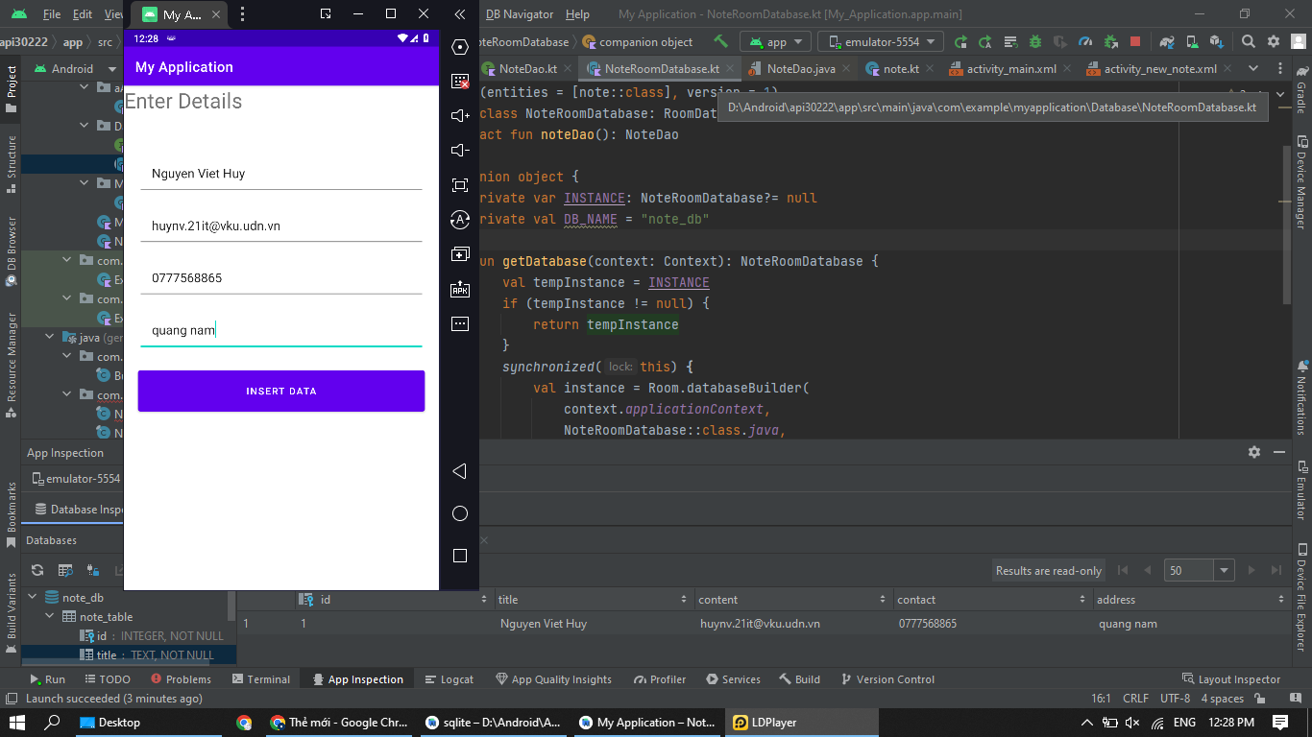

https://github.com/vhuyboy369/L-n-2-Gi-a-k-LTD-_4